**Sunday, April 21 – WASHINGTON, DC…ROME**

Easter Sunday, *“Buona Pasqua Confirmandi!“*  We depart from **WASHINGTON’s Dulles Airport** on a United non-stop flight to **ROME** as true Pilgrims (*Pellegrini*); dinner and breakfast aloft: “*Buon appetito!* “

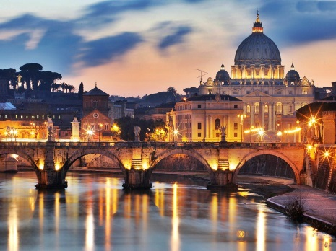

**Monday, April 22 – ROME**

We arrive at Leonardo Da Vinci Airport in **ROME***—“Benvenuto Pellegrini!”*-- where we will be met by our Renaissance Group Tour Escort (once we’ve cleared customs.) We “*Pellegrini”* then board our private, deluxe motorcoach for a short ride to St. Paul’s Basilica for Mass. After celebrating the “Source and Summit” of our faith, we will visit the major basilicas of the Eternal City, “*Roma*” including the “*Scala Santa”* (Holy Steps). We check into our hotel for some relaxation, *“Bellissimo!”* In early evening, there will be a walking tour of the Trevi Fountain, the Spanish ***Rome***

Steps, Pantheon, and dinner at Piazza Navona. *“Buona Notte Pellegrini!”*

**Tuesday, April 23 – ROME**

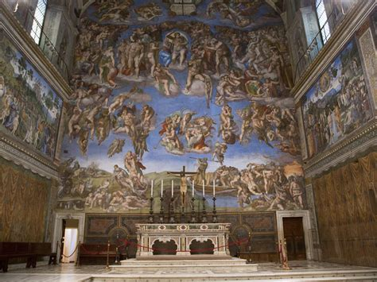After breakfast *(colazione*) in our hotel, we will ride to St. Peter’s Basilica for a visit to the Sistine Chapel, the Vatican Museums and the Basilica itself. The rest of the afternoon is at leisure. At this time, there will be optional tours to other landmark sites you may want to visit, such as the Roman Forum and Colesseum. Or, you may wish to enjoy a culturally Italian experience at an outdoor square

***The Sistine Chapel***

*(piazza)* by enjoying an afternoon espresso *(café espresso)* or explore some local shopping. There will be an early evening Mass, *(La Messa)* at a Catholic church *(chiesa Cattolica)* which is within walking distance of our hotel. We will conclude the evening with dinner, *(cena)* at a local restaurant *(ristorante)*. “*Buon appetito, Confirmandi!”*

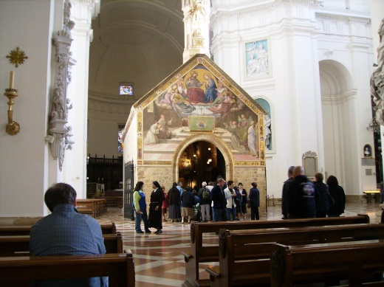

**Wednesday, April 24 – ROME…ORVIETO…ASSISI**

After breakfast *(colazione)* in our hotel, we will check out and head back to St. Peter’s for the Papal Audience. After enjoying this unique opportunity with the Holy Father *(il Santo Padre)* and a quick lunch *(un pranzo)*, we depart **ROME.** Having enoyed the busyness of **ROME**, we ***Porziuncola***

now head for the slower paced region of **Umbria**. We visit **ORVIETO** to

venerate the relics *(reliquie)* of a **Eucharistic Miracle** which led Pope Urban

in 1264 to establish the feast we still honor today called “Corpus Christi” (affirming the presence of Our Lord’s true Body and Blood to be present in the Eucharist.) Eucharistic Miracles such as this inspired St. Thomas Aquinas to write renowned hymns like, “O Salutauris Hostia” which we still sing today. We enjoy Mass *(La*

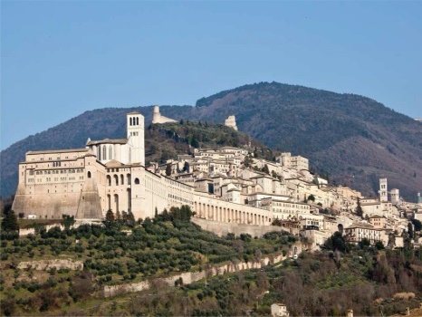 *Messa)* at Orvieto’s Duomo**.** Concluding our worship in **Orvieto**, we continue on to **ASSISI.** We first stop at the Church of *Santa Maria degli Angeli* for a visit. Next, we view the *Porziuncola* (*pictured above*; a tiny church within Santa Maria degli Angeli) originally erected by hermits. In 1208, St. Francis had restored it with his own hands, making it his home and that of his first disciples. We check into our hotel and enjoy a dinner at a local restaurant after another full day. What a day, Pilgrims! *(Che giornata, Pellegrini!)*

***Assisi***

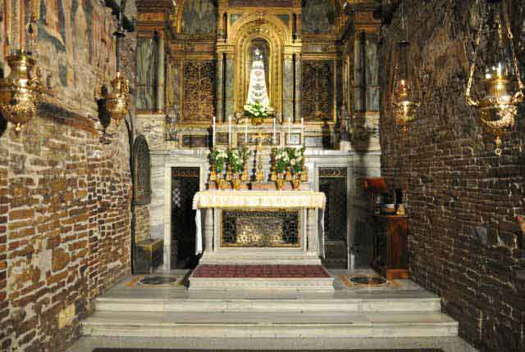

**Thursday, April 25 – ASSISI…SIENA…ASSISI**

After breakfast *(colazione)* in our hotel, Mass *(La Messa)* will be celebrated at the tomb of St. Francis *(San Francesco)*. An actual friar will join us and lead our tour of the basilica *(la basilica)*. We will see paintings by Italian artists Cimabue and Giotto. The friar *(il frate)* will also show us around this medieval city, stopping finally at the ***Eucharistic Miracle, Lanciano***

***Holy House of Mary*** Basilica of St. Clare. Lunch *(pranzo)* will be on our own *(da soli)* but we will reconvene

as a family of *“Pellegrini”* for dinner to sample the delicacies of this Umbrian town. Next stop is **SIENA** to visit the Basilica of San Domenico where St. Catherine attended Mass and where you will see the house *(casa)* in which she was raised. There will be a half-day of sightseeing this famous town, known for its cuisine *(cucina)*, museums *(musei)*, Medieval cityscapes, and the “*Palio”* which is a well-known Italian horse race held twice a year. 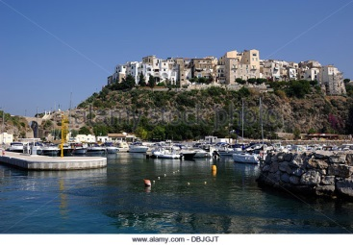We then return to ASSISI. *“Buona Notte, Pellegrini!”*

***Sperlonga***

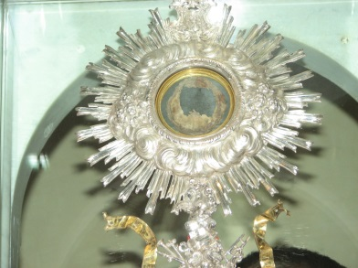**Friday, April 26 – ASSISI…LORETO…LANCIANO…SPERLONGA**

After breakfast in our hotel, we depart for **LORETO,** in the **Marche** region of central Italy. We will attend Mass at the basilica which contains the “Holy House

of Mary” (the actual structure/house in which our Lady was born and was greeted by the Angel Gabriel for the Annunciation.) Afterwards, we will tour the basilica and visit the gift shop. We then depart for **LANCIANO** in the **Abruzzo** region of central Italy, where we will together enjoy a “pranzo.” We will visit the “Church of the Eucharistic Miracle” located in the center of

***Gaeta* Lanciano**. This is the site of the first **Eucharistic Miracle** and called by many

to be the *greatest* of such Eucharistic Miracles. During the 700’s, an unnamed monk of St. Basil who had doubted the true transubstantiation of the Eucharist was celebrating Mass at this church. During the Consecration, the Host turned to real flesh and the wine to real blood. This was witnessed by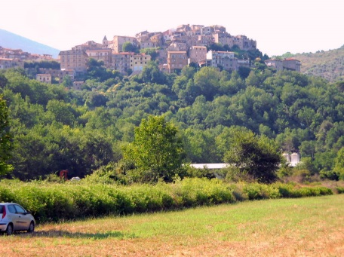 the entire congregation present. We will venerate the relics *(reliquie)*. We next depart for **SPERLONGA,** which is in the southern **Lazio** region of central Italy. We will check into our hotel and have some time to relax *(rilassarsi!)* before enjoying a ***Lenola***

pizza and gelato evening. Delicious! All is well, Pilgrims. *“Delizioso! Tutto bene, Pellegrini.”*

**Saturday, April 27 – SPERLONGA…GAETA…LENOLA…SPERLONGA**

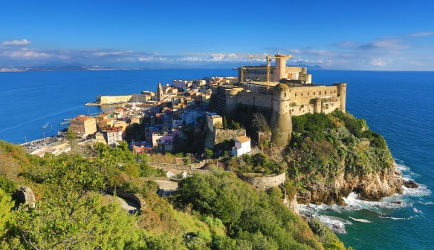After “colazione” in our hotel, we will take a short ride to **GAETA**, still in the Lazio region**.** When Jesus died on the cross *(la croce)*, the earth shook causing a mountain, many miles away –in Gaeta, Italy --to split. A large rock broke loose and got stuck further down between the walls and the cleft. In the 14th century, a small chapel *(una piccola capella)*, devoted to the *Crucifix (la Crocifisso)*, was built on top of this rock (questa roccia). Many Popes, kings, and Bishops have come to pray at this Split Mountain as well as saints such as Pope Pius IX, Bernardino of Siena, Ignatius of Loyola, Paul of the Cross, and St. Philip Neri. According to the legend, St. Philip Neri lived in the insides of the Split Mountain finding shelter on a stone pallet, known today as *"St. Philip Neri's bed."* You will also visit *La Cappella D’oro* where Pius IX celebrated Mass during his exile (the result of political unrest) in 1848. In this chapel *(questa capella)*, he received the inspiration for proclaiming the dogma of the Immaculate Conception. Proceed towards the mountains (le montagne) and a hilltop town of **LENOLA** where we attend the Holy Sacrifice of the Mass in the newly-dedicated basilica named “La Madonna del Colle” (Madonna of the Hill). We will enjoy a sumptuous “pranzo” here before returning to **SPERLONGA** with some free time in the evening and dinner on your own. Enjoy your evening! (Goditi la serata!)

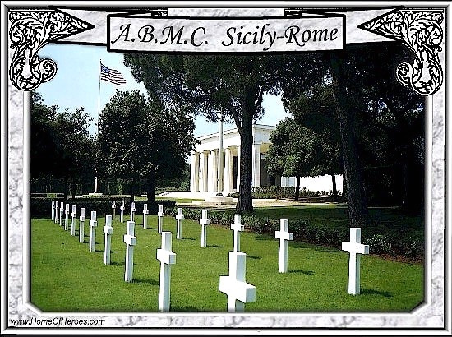

**Sunday, April 28 – SPERLONGA…NETTUNO…CASTEL GANDOLFO**

After “colazione” in our hotel, we ride to **NETTUNO** for our younger *“Pellegrini.”* Still in Lazio, we visit the Shrine of St. Maria Goretti. A crypt houses the mortal remains of the saint. Mass will be celebrated in this church *(chiesa)* which also keeps a valuable polychromed wooden statue of Our Lady of Grace (La Nostra Signora della Grazia) which is honored by the town with a procession every year on the first Saturday of May. At the north edge of town is the Sicily-Rome American Cemetery and Memorial where over 7,800 US soldiers are buried.

***Sicily-Rome American Cemetery and Memorial***

We continue on to **CASTEL GANDOLFO**, still in the **Lazio** region, which is the summer residence *(la residenza estiva)* of the Pope. We will enjoy a guided tour, the breathtaking gardens and time to peruse in their gift shop. “Pranzo” will be on our own *(da soli)* with time to enjoy this little, picturesque town. Dinner will be together *(insieme)* at a local “ristorante.” This is our last night in Italy. (Questa e la nostra ultima notte in Italia.)

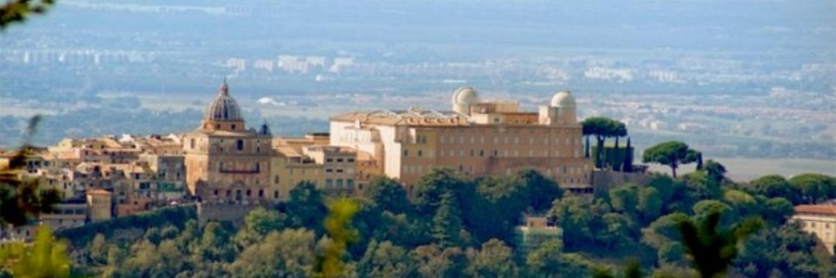

***Castel Gandolfo***

**Monday, April 29 –  CASTEL GANDOLFO…ROME…WASHINGTON, DC**

After “colazione” in our hotel, we will check out and depart for Rome Airport for our non-stop flight to **WASHINGTON, DC**. We will arrive on the same day.

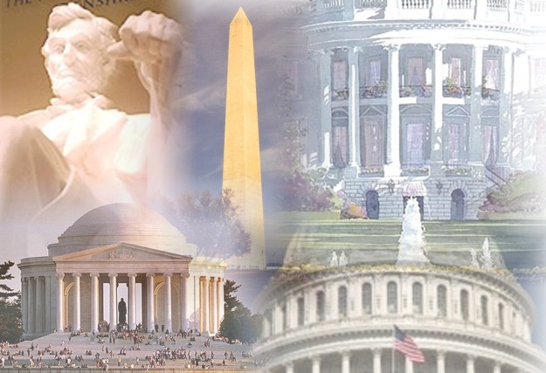

**Welcome Home!**

***Benvenuto a casa!***

***Renaissance Group LLC***

*20897 Planetree Forest Court*

*Potomac Falls, Virginia 20165*

*Tel: (703) 430-0030 (800) 304-8259*

*Fax: (703) 430-1440*

[*ezio@rengp.com*](mailto:ezio@rengp.com)

[*www.rengp.com*](http://www.rengp.com/)

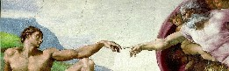

Sources

Catholic Education Resource Center

CatholicEducation.org

Get Fed: Feed Your Faith/Gretchen Filz

New Advent

EWTN